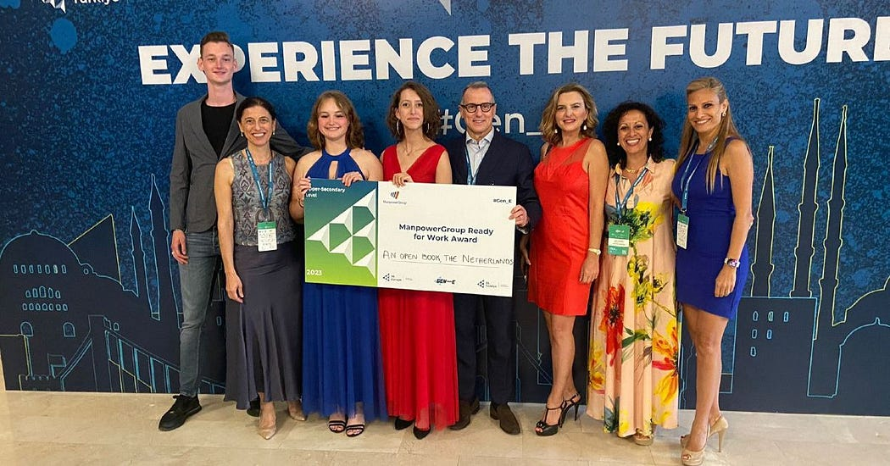

Growing together: building success with the right team

Each one of the team members contributes to the success of a project. Do you want to find out how An Open Book, a group of young people who competed in the Gen-E competition, an event supported by ManpowerGroup, came together to bring innovation into learning and how cooperation pushed them to become better professionals? Keep reading!
Giving life to a project requires a lot of business knowledge, dedication, and willingness to get better day after day. However, it is also about selecting the ideal people to accomplish each duty and grow alongside you. We all have unique skill sets that we can bring to our team, adding value to what we create together.
An Open Book, as the winning team of the 2023 Ready for Work award, a ManpowerGroup prize handed out during the Junior Achievement Gen-E competition, are a great example of this. During their time at school, they were challenged to create a new product with the potential to be introduced to the market. After extensive brainstorming sessions with all the team and a lot of reflection and research, they came up with this start-up idea — that today is a lot more than just a dream.

Where teamwork and innovation come together
Have you ever struggled with holding a heavy or big book while reading for a while? This was exactly the starting point of An Open Book when they decided to repurpose unused wood by transforming it into a diamond-shaped wooden tool to hold books during reading: the Boekmaat. This little tool not only improves everyone’s reading experience but also reduces waste and contributes to a greener future.
“We strive to make reading easier and more comfortable for booklovers. We would love to inspire everyone to open books again and find their love for reading. With the Boekmatt it is possible to gain a better grip, making it more convenient to read at all places, such as reading on the beach, in the metro, train, or even while lounging upside down on your couch at home.”, says the An Open Book team, “Additionally, we also aim to make a positive impact on older individuals and those who struggle to hold a book due to conditions like arthritis or rheumatism to continue enjoying a good book.”
Also, it is important to be aware that every single step you take when launching a new business has an impact in the world. With that in mind, An Open Book only uses high quality wood that would otherwise be discarded and considered waste. By giving this wood a second life, this project contributes to a greener and more sustainable world.
Obviously, building a project and working together with a team takes a lot of effort: from thinking about the first concept to seeing the end results, there are a lot of steps every single team must take. And this is exactly where every single member comes together to play an important role. Because if everyone is moving forward together, then success takes care of itself.
According to the team, “The experience was such an amazing opportunity. Not only to only learn from all the talented start-ups from all other countries but also to connect with everyone participating. We are proud to say that An Open Book grew even stronger together as a team and that we will take this experience as something that we will always remember, learn from and look back at.”


A successful innovation gathering
Focused on boosting the beginning of the new generations’ careers, Gen-E 2023, a signature event organized by renowned and influential companies from all over Europe, is a way to promote the improvement of skills as well as the sharing of knowledge and experiences. This year’s competition brought together more than 800 young entrepreneurs, teachers, business partners and policymakers from across Europe in Istanbul for an impressive showcase of business ideas and innovation spirit.
Are you thinking about starting your own business and don’t know how to make it real? Get yourself and all your team involved with this project along with ManpowerGroup and Junior Achievement and become part of the next generation of entrepreneurs.

